Adding/Editing/Removing

Members from your Club Roster
Club Runner makes it quite simple to maintain your club roster on the CI Web site.

Adding members
Adding new members is done from the Active Members List page for your club. As shown in the graphic below, select the Add New Member button (colored orange) towards the right side of the screen:
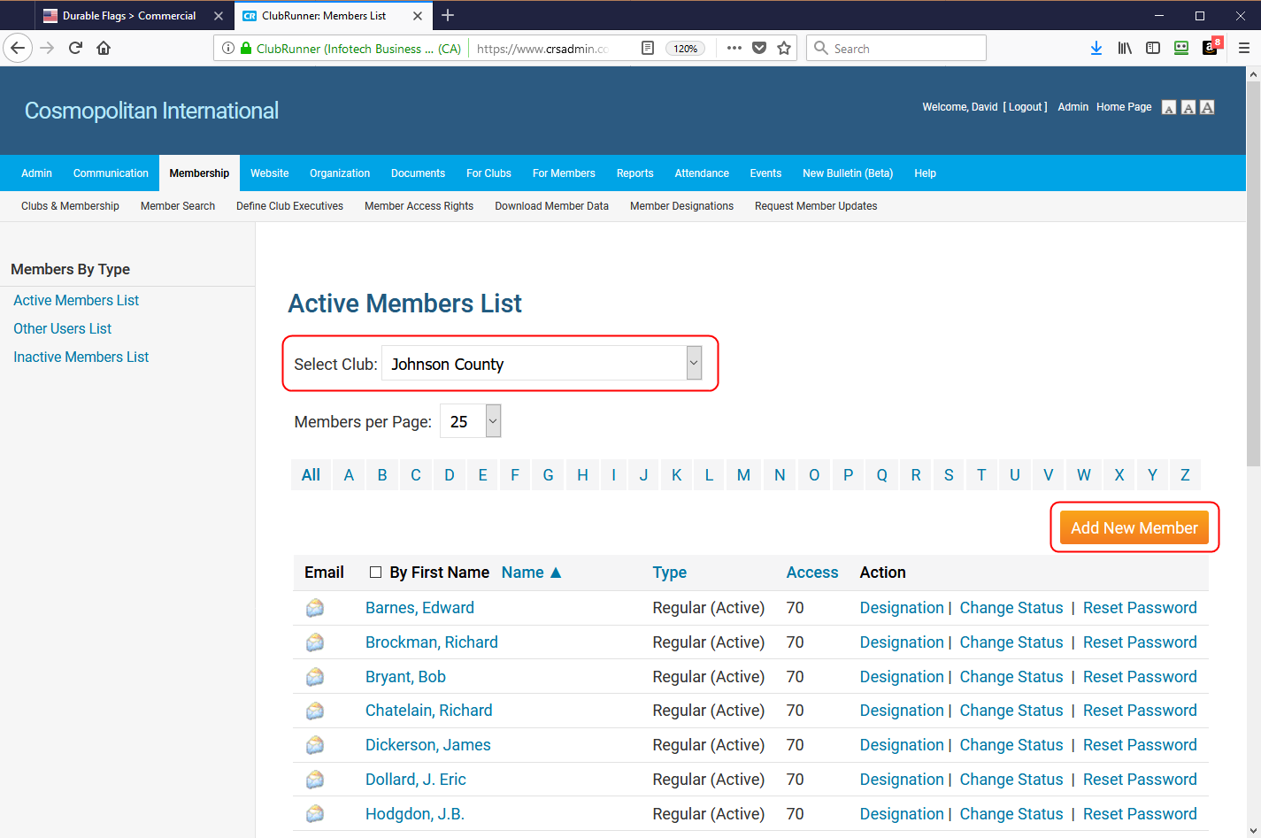
Figure 1: Active Members List
For new members, you must fill in the items shown on the New Member screen that have a red title to the left of the field. These are required fields. They are all shown in the dialog below:
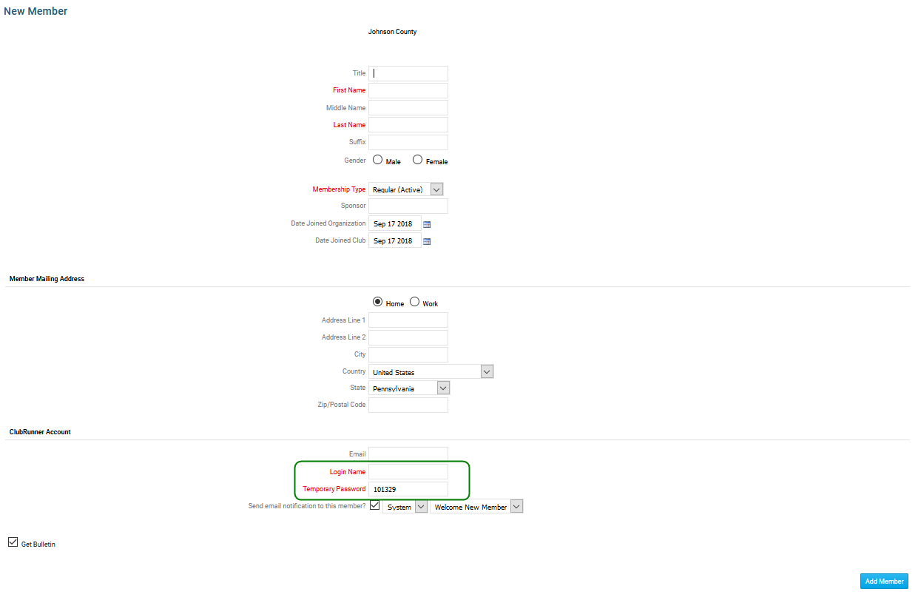
Figure 2: New Member Dialog…
The two circled in green at the bottom of the dialog will fill in automatically as you fill in the required fields in the first section (top portion of the form). Once these fields are filled in, press the Add Member button (blue button) in the lower right corner of the form.
After the new member is added, you can then edit other portions of their record and complete the information. You will want to add the items circled in red below at a minimum:
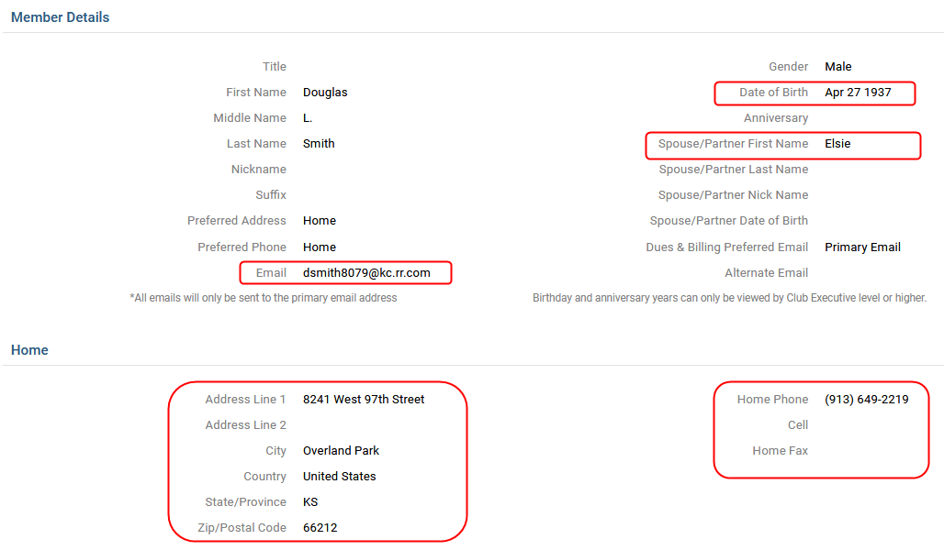
Figure 3: Additional Fields for a new member…
And finally, if you click on the Privacy tab on the member profile dialog, you will want to edit this and check the ClubRunner Connect option:
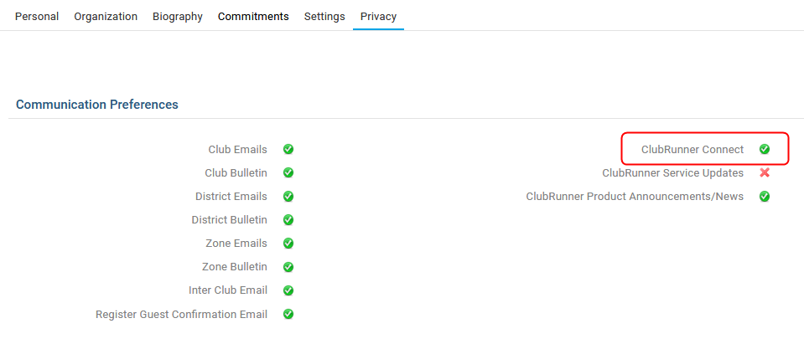
Figure 4: Privacy settings in the User Profile…

Editing a Member’s Information
Member information is access in a similar manor. You first select the Active Member List for your club, and then click on either the alphabet for the last name, or the user name if it is already listed in the first query. So accessing the user information is done via the User Name listed. If you club has more than 25 members, there will be multiple pages available. They are typically listed alphabetically by last name, although you can switch that to sort by first name if you wish.
Once you click on the User Name, you will be presented with the figure 3 details above, with both an Organization and Privacy tab that will contain information for Cosmo members. The Biography and Commitments tabs will only contain information if either you member has provided the Biography info, or your club is using the Club Runner as a hosting platform.
Each tab allows you to select the Edit mode, and alter the information available to you on that tab. You have to save each tab as you work though the editing process.

Removing a Member
Removing a member is a simple process on the Club Runner system. You need to first go the the Active Members List for your club, and select the user. This can be done in one of two ways: First using the Alphabetical toolbar to select the alphabet that the last name starts with, or Second, scrolling through the pages of members until you get to the member you need to alter.
Once you have the member shown on the screen, select the Change Status option, as shown below:
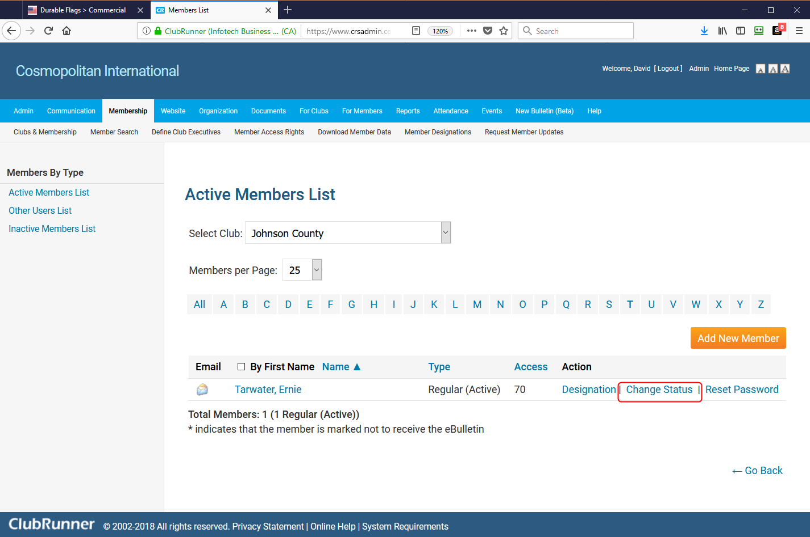
Figure 5: Change Status of current member…
The Change Status allows you to remove the current member by selecting the Terminate Membership option, as shown below:
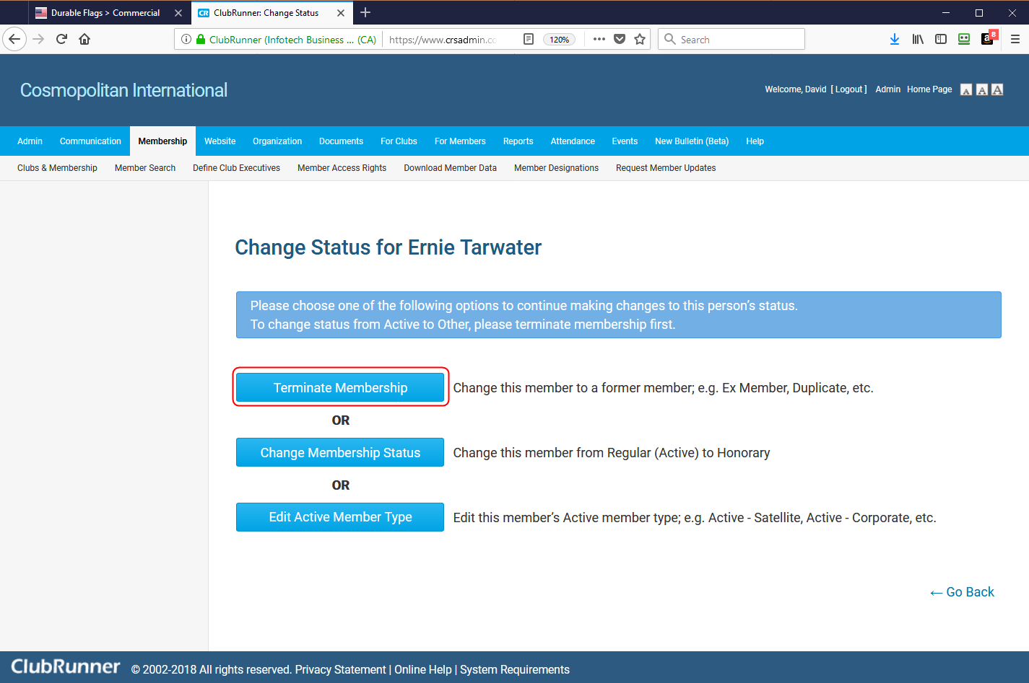
Figure 6: Terminating a Member…
Once you confirm that you want the member terminated from Active Status, they will be listed on the Inactive Member listing. Their history will be maintained in case they decide to become active again.

